
UNIVERSITY OF ASIA PACIFIC
Department of Computer Science & Engineering

Course Code: CSE 212
Course Title: Database Systems Lab
Section: A (1)

Project Title:
Hotel Management System

Submitted To:
Nadeem Ahmed
Assistant Professor,
Department of CSE,
University of Asia Pacific

Submitted By:
23201009 Md. Momin Ali Rifat
23201023 Nazmuz Saif
23201033 Kamrul Hasan Siam
23201050 Tahsin Rahman Khan

Table of Contents
1. Introduction 1
1.1 Objective 1
1.2 Functionalities 1
1.3 Target Users 1
2. ER Design 2
2.1 Entities 2
2.2 Attributes 2
2.3 Relationships 5
3. Schema Design 6
3.1 Table 6
3.2 Attributes 9
4. Entity-Relationship Diagram (ERD) 9
5. Schema Diagram………………………………………10
6. Table Creation………………………………………….10
7. Data Insertion………………………………………….10
8. Query(Question, DML Query, Output SS)……….10
9. Database Objects………………………………..…….22
10. CEP mapping (K, P, A)……………………………….24

1. Introduction

1.1 Objective
The objective of this project is to design and implement a Hotel Management System that efficiently manages and organizes data related to hotel operations, including guests, bookings, payments, rooms, services, employees, hotels, room types, and roles. The system aims to digitize and streamline hotel processes, reduce manual errors, and provide scalable data management to support hotel operations.

1.2 Functionalities
This system can primarily be used to:
- Manage guest registrations and personal information.
- Track room bookings, check-in, check-out dates, and booking status.
- Record and process guest payments securely.
- Manage hotel rooms, their types, price, and availability.
- Track services availed by guests during their stay.
- Maintain employee information and assigned job roles.
- Manage hotels with their location and facility details.

1.3 Target Users
- Hotel staff responsible for managing bookings, rooms, services, and payments.
- Guests who want to book rooms and avail hotel services.
- Hotel administrators to manage employees, hotels, and room types.

2. ER Design

2.1 Entities
- Guest – Stores guest information.
- Booking – Tracks room reservations made by guests.
- Payment – Records the payments done by guests.
- Service – Tracks the services availed by guests.
- Hotel – Contains hotel details such as location.
- Room – Stores data about hotel rooms.
- RoomType – Defines categories and features of rooms.
- Employee – Maintains staff information for each hotel.
- Role – Defines job roles for employees.

Attributes

1. Hotel
- Hotel_ID
- Name
- Address
- City
- Country
- ZipCode
- PhoneNumber
- Email

2. Room Type
- Type_ID
- TypeName
- Price_per_night

3. Room
- Room_ID (PK)
- Room_No.
- Status

4. Guest
- Guest_ID
- First_Name
- Last_Name
- Phone_Number
- NID_No.
- Guest_Email

5. Booking
- Booking_ID
- Check_in_Date
- Check_out_Date
- Booking_Status

6. Payment
- Payment_ID
- Payment_Date
- Payment_Amount
- Payment_Method
- Status
- Discount_Amount

7. Service
- Service_ID
- Service_Name
- Service_Charge
- Details

8. Role
- Role_ID (PK)
- RoleType

9. Employee
- Employee_ID
- First_Name
- Last_Name
- Salary
- Phone_Number
- NID_No.

Relationships

1. Hotel - Service (Provides): One-to-Many
A Hotel Provides multiple Services, but each Service is provided by only one Hotel.

2. Hotel - Employee (Works): One-to-Many
A Hotel employs multiple Employees, but each Employee Works for only one Hotel.

3. Hotel - Booking (In): One-to-Many
A Hotel can be associated with multiple Bookings, but each Booking is In only one Hotel.

4. Hotel - Room (Has): One-to-Many
A Hotel can Has multiple Rooms, but each Room belongs to only one Hotel.

5. Guest - Payment (Has): One-to-Many
A Guest can have multiple Payment records (for different bookings or services), but each Payment is associated with only one Guest.

6. Guest - Booking (Makes): One-to-Many
A Guest can make multiple Bookings, but each Booking is associated with only one Guest.

7. Guest - Service (Takes): One-to-Many
A Guest can Takes multiple Services, and a single Service can be Takesn by one Guests.

8. Booking - Room (Has): One-to-One
Each Booking is for one specific Room, and that Room is associated with only one Booking (at a time).

9. Room - Room Type (Belongs to): Many-to-One
Multiple Rooms can Belong to the same Room Type, but each Room is of only one specific Room Type.

10. Employee - Role (Emp_Role): Many-to-One
Multiple Employees can have the same Role, but each Employee has only one Role.
3. Schema Design

3.1 Table
- Guest – Stores guest information.
- Booking – Tracks room reservations made by guests.
- Payment – Records the payments done by guests.
- Service – Tracks the services availed by guests.
- Hotel – Contains hotel details such as location.
- Room – Stores data about hotel rooms.
- RoomType – Defines categories and features of rooms.
- Employee – Maintains staff information for each hotel.
- Role – Defines job roles for employees.
10. Emp_Role – Defines the shifting of an employees.

Attributes
In ERD → Database conversion:
- Entity → Table
- Attribute → Column
- Primary key → Primary key
- Relationship → Foreign key

1. Hotel
- Hotel_ID (PK)
- Name
- Address
- City
- Country
- ZipCode
- PhoneNumber
- Email

2. Room Type
- Type_ID (PK)
- TypeName
- Price_per_night

3. Room
- Room_ID (PK)
- Hotel_ID (FK → Hotel)
- Room_No.
- Type_ID (FK → Room Type)
- Status

4. Guest
- Guest_ID (PK)
- First_Name
- Last_Name
- Phone_Number
- NID_No.
- Guest_Email

5. Booking
- Booking_ID (PK)
- Guest_ID (PK,FK → Guest)
- Hotel_ID (FK → Hotel)
- Room_ID (PK,FK → Room)
- Check_in_Date
- Check_out_Date
- Booking_Status

6. Payment
- Payment_ID (PK)
- Guest_ID (FK → Guest)
- Payment_Date
- Payment_Amount
- Payment_Method
- Status
- Discount_Amount

7. Service
- Service_ID (PK)
- Guest_ID (FK → Guest)
- Hotel_ID (FK → Hotel)
- Service_Name
- Service_Charge
- Details

8. Role
- Role_ID (PK)
- RoleType

9. Employee
- Employee_ID (PK)
- Role_ID (FK → Role)
- Hotel_ID (FK → Hotel)
- First_Name
- Last_Name
- Salary
- Phone_Number
- NID_No.

10. Emp_Role (Linking Table for Employee ↔ Role)
- Role_ID (PK, FK → Role)
- Employee_ID (PK, FK → Employee)
- Shift

4. Entity-Relationship Diagram (ERD)
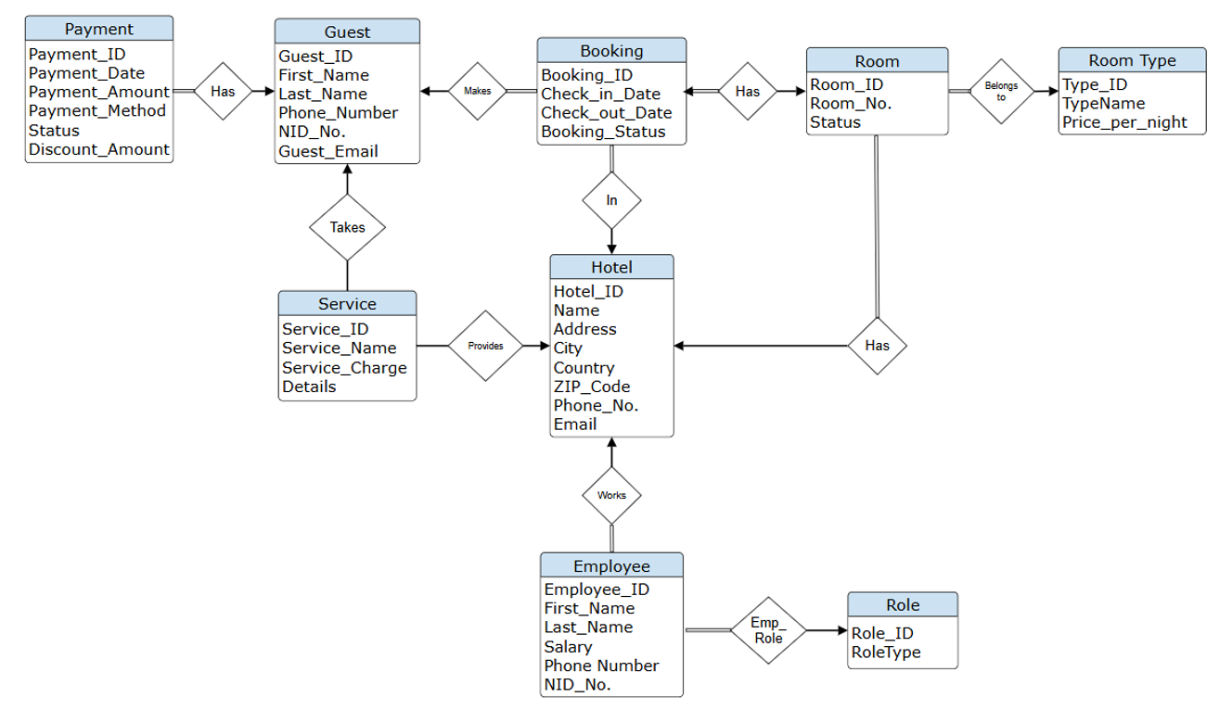

5. Schema Diagram

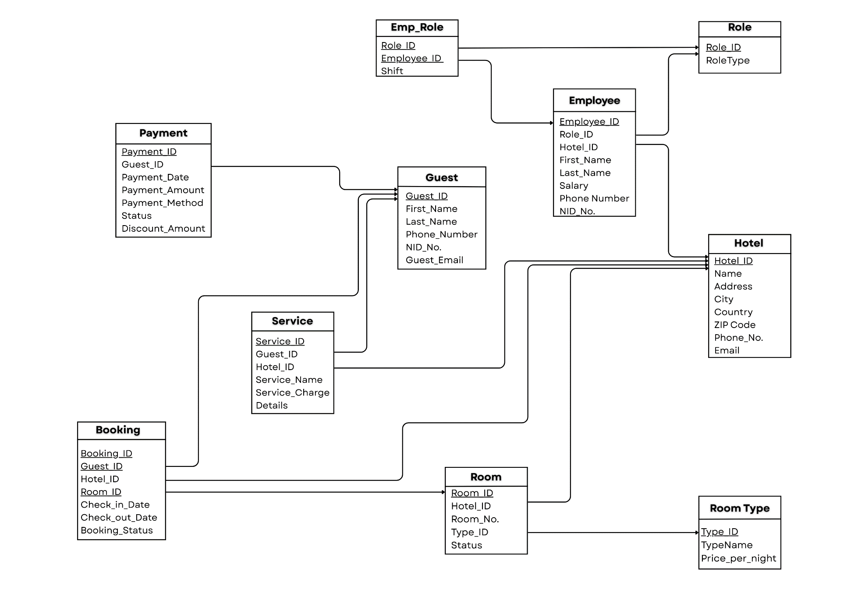

6. Table Creation
create database Hotel_Management_System
use [Hotel_Management_System]

create table Role
(
Role_ID int primary key,
RoleType varchar(50) not null
)

create table Hotel
(
Hotel_ID int primary key,
Name varchar(100) not null,
Address varchar(255),
City varchar(100),
Country varchar(100),
ZIPCode varchar(20),
Phone_No varchar(20),
Email varchar(100)
)

create table Employee
(
Employee_ID int primary key,
Role_ID int not null,
Hotel_ID int not null,
First_Name varchar(50) not null,
Last_Name varchar(50),
Salary decimal(10, 2),
Phone_Number varchar(20),
NID_No varchar(20) unique,
foreign key (Role_ID) references Role(Role_ID),
foreign key (Hotel_ID) references Hotel(Hotel_ID)
)
create table Emp_Role
(
Role_ID int,
Employee_ID int,
Shift varchar(50),
primary key (Role_ID, Employee_ID),
foreign key (Role_ID) references Role(Role_ID),
foreign key (Employee_ID) references Employee(Employee_ID)
)

create table Guest
(
Guest_ID int primary key,
First_Name varchaR(50) not null,
Last_Name varchar(50),
Phone_Number varchar(20),
NID_No varchar(20) unique,
Guest_Email varchar(100)
)

create table RoomType
(
Type_ID int primary key,
TypeName varchar(50) not null,
Price_per_night decimal(10, 2) not null
)

create table Room
(
Room_ID int primary key,
Hotel_ID int not null,
Room_No varchar(10) not null,
Type_ID int not null,
Status varchar(50),
foreign key (Hotel_ID) references Hotel(Hotel_ID),
foreign key (Type_ID) references RoomType(Type_ID),
)

create table Booking
(
Booking_ID int,
Guest_ID int not null,
Hotel_ID int not null,
Room_ID int not null,
Check_in_Date date not null,
Check_out_Date date not null,
Booking_Status varchar(50),
primary key(Booking_ID,Guest_ID,Hotel_ID),
foreign key (Guest_ID) references Guest(Guest_ID),
foreign key (Hotel_ID) references Hotel(Hotel_ID),
foreign key (Room_ID) references Room(Room_ID)
)

create table Payment
(
Payment_id int primary key,
Guest_ID int not null,
Payment_Date date not null,
Payment_Amount decimal(10, 2) not null,
Payment_Method varchar(50),
Status varchar(50),
Discount_Amount decimal(10, 2) default 0.00,
foreign key (Guest_ID) references Guest(Guest_ID)
)

create table Service
(
Service_id int primary key,
Guest_id int not null,
Hotel_id int not null,
Service_Name varchar(100) not null,
Service_Charge decimal(10, 2) not null,
Details TEXT,
foreign key (Guest_ID) references Guest(Guest_ID),
foreign key (Hotel_ID) references Hotel(Hotel_ID)
)

7. Data Insertion
use [Hotel_Management_System]

insert into [dbo].[Role] values
('101','General Manager'),
('102','Office Manager'),
('103','Receptionist'),
('104','Housekeeping Staff'),
('105','Head Chef'),
('106','Chef'),
('107','Security Guard'),
('108','Waiter'),
('109','Driver'),
('110','Accountant'),
('111','Event Manager'),
('112','IT Support')

insert into [dbo].[Hotel] values
('1','Dhaka Royal Vista','72, Gulshan Avenue','Dhaka','Bangladesh','1212','02-8833445','dhakaroyal@hotel.com'),
('2','Coxs Sea Pearl','15 Sea Beach Road','Coxs Bazar','Bangladesh','4700','0341-67890','coxspearl@hotel.com'),
('3','Sylhet Green Resort','Sreemangal Road','Sylhet','Bangladesh','3100','0821-112233','sylhetgreen@hotel.com'),
('4','Chittagong Bay View','A-1, CDA Avenue','Chittagong','Bangladesh','4000','031-445566','ctgbayview@hotel.com'),
('5','Rajshahi Heritage Inn','Main Road, Shaheb Bazar','Rajshahi','Bangladesh','6000','0721-789012','rajshahi.heritage@hotel.com'),
('6','Khulna River Side','Jessore Road, Rupsa','Khulna','Bangladesh','9000','041-334455','khulnariver@hotel.com'),
('7','Barishal Lake Breeze','Amtala Road','Barishal','Bangladesh','8200','0431-556677','barishallake@hotel.com'),
('8','Rangpur City Inn','Station Road','Rangpur','Bangladesh','5400','0521-334455','rangpurcity@hotel.com'),
('9','Mymensingh Comfort Stay','Zilla Road','Mymensingh','Bangladesh','2200','091-112233','mymensinghstay@hotel.com'),
('10','Gazipur Forest Retreat','Rajendrapur Road','Gazipur','Bangladesh','1700','0921-889900','gazipurretreat@hotel.com'),
('11','Kuakata Ocean View','Beach Road','Kuakata','Bangladesh','8600','0441-334455','kuakataocean@hotel.com'),
('12','Pabna Comfort Hotel','Central Road','Pabna','Bangladesh','6600','0731-223344','pabnacomfort@hotel.com')

insert into [dbo].[Employee] values
('201','101','1','Momin','Rifat','90000.00','01811194021','NID2598412578'),
('202','102','1','Rifat','Khan','55000.00','01854994056','NID6598412547'),
('203','103','2','Nazmuz','Saif','65000.00','01869854125','NID5985412567'),
('204','105','2','Saif','Hasan','62000.00','01598426589','NID5982140216'),
('205','104','3','Montasim','Monti','32000.00','01569854712','NID1254789201'),
('206','106','3','Kamrul','Hasan','50000.00','01625474159','NID6985410023'),
('207','107','4','Momin','Mahin','30000.00','01754821630','NID0214577854'),
('208','109','4','Siam','Kabir','38000.00','01785412593','NID8901234567'),
('209','110','5','Arafat','Kabir','45000.00','01911223344','NID9998887771'),
('210','111','6','Maruf','Ahmed','48000.00','01866778899','NID1112223334'),
('211','112','7','Sohag','Faraji','50000.00','01755443322','NID5556667778'),
('212','106','8','Hasib','Rahman','47000.00','01988990011','NID3334445556')

insert into [dbo].[Emp_Role] values
('101','201','Morning'),
('102','202','Day'),
('103','203','Evening'),
('105','204','Day'),
('104','205','Night'),
('106','206','Day'),
('107','207','Night'),
('109','208','Day'),
('110','209','Morning'),
('111','210','Day'),
('112','211','Evening'),
('106','212','Day')

insert into [dbo].[Guest] values
('301','Momin','Rifat','01300112233','NID1122334455','momin@gmail.com'),
('302','Montasim','Kabir','01400445566','NID2233445566','montasim@gmail.com'),
('303','Nazmuz','Saif','01500778899','NID3344556677','nazmuz@gmail.com'),
('304','Siam','Ali','01600101010','NID4455667788','ali@gmail.com'),
('305','Kamrul','Islam','01700202020','NID5566778899','kamrul@gmail.com'),
('306','Tahsin','Hossain','01800303030','NID6677889900','tahsin@gmail.com'),
('307','Momin','Islam','01900404040','NID7788990011','islam@gmail.com'),
('308','Nazmuz','Siam','01310505050','NID8899001122','siam@gmail.com'),
('309','Arafat','Kabir','01322001122','NID9900112233','arafat@gmail.com'),
('310','Maruf','Ahmed','01433002233','NID8800223344','maruf@gmail.com'),
('311','Sohag','Faraji','01544003344','NID7700334455','sohag@gmail.com'),
('312','Hasib','Rahman','01655004455','NID6600445566','hasib@gmail.com')

insert into [dbo].[RoomType] values
('401','Standard Single','3500.00'),
('402','Deluxe Double','6000.00'),
('403','Executive Suite','12000.00'),
('404','Family Room','8500.00'),
('405','Presidential Suite','30000.00'),
('406','Twin Bed','4500.00'),
('407','King Deluxe','9500.00'),
('408','Economy Single','2800.00'),
('409','Luxury Suite','15000.00'),
('410','Junior Suite','7500.00')

insert into [dbo].[Room] values
('501','1','101','401','Occupied'),
('502','1','205','402','Available'),
('503','2','301','403','Occupied'),
('504','2','102','401','Available'),
('505','3','404','404','Maintenance'),
('506','3','501','405','Available'),
('507','4','601','406','Occupied'),
('508','5','202','402','Available'),
('509','6','203','407','Occupied'),
('510','7','204','408','Available'),
('511','8','205','409','Occupied'),
('512','9','206','402','Available')

insert into [dbo].[Booking] values
('601','301','1','501','2025-10-01','2025-10-03','Checked-Out'),
('602','302','2','503','2025-10-02','2025-10-14','Checked-In'),
('603','303','4','507','2025-10-03','2025-10-18','Confirmed'),
('604','304','1','502','2025-10-04','2025-10-05','Cancelled'),
('605','305','5','508','2025-10-05','2025-10-12','Confirmed'),
('606','301','3','506','2025-10-06','2025-10-25','Pending'),
('607','306','2','504','2025-10-07','2025-10-07','Confirmed'),
('608','309','6','509','2025-10-08','2025-10-13','Checked-In'),
('609','310','7','510','2025-10-09','2025-10-18','Confirmed'),
('610','311','8','511','2025-10-10','2025-10-15','Pending'),
('611','312','9','512','2025-10-11','2025-10-16','Confirmed'),
('612','307','3','505','2025-10-12','2025-10-19','Cancelled')

insert into [dbo].[Payment] values
('701','301','2025-10-01','7000.00','bKash','Paid','0.00'),
('702','302','2025-10-02','60000.00','Credit Card','Paid','0.00'),
('703','303','2025-10-03','36000.00','Bank Transfer','Pending','0.00'),
('704','304','2025-10-04','24000.00','Cash','Paid','0.00'),
('705','305','2025-10-05','12000.00','Rocket','Paid','500.00'),
('706','301','2025-10-06','20000.00','Nagad','Pending','0.00'),
('707','306','2025-10-07','14000.00','Cash','Paid','400.00'),
('708','308','2025-10-08','0.00','N/A','Failed','0.00'),
('709','309','2025-10-09','18000.00','Credit Card','Paid','0.00'),
('710','310','2025-10-10','9500.00','bKash','Paid','300.00'),
('711','311','2025-10-11','15000.00','Bank Transfer','Pending','0.00'),
('712','312','2025-10-12','6000.00','Cash','Paid','0.00')

insert into [dbo].[Service] values
('801','301','1','dinner buffet','1500.00','one person, first night special, dine and delight offer – buy 1 get 2'),
('802','302','2','spa massage','4000.00','full body aromatherapy, relax your mind and soul'),
('803','301','1','laundry','850.00','4 shirts, 2 trousers, complimentary fragrance finish'),
('804','303','4','mezban dinner','3000.00','traditional bangladeshi feast, buy 1 get 2 limited offer'),
('805','304','1','room service','1200.00','late-night snacks, complimentary dessert included'),
('806','306','2','beach gear rental','500.00','umbrella and chair set, enjoy the breeze with comfort'),
('807','305','5','mini bar','750.00','refreshing drinks and light snacks, buy 2 get 1 free'),
('808','307','6','airport transfer','2500.00','one-way drop-off, professional service with care'),
('809','309','6','dinner buffet','1800.00','complimentary welcome drink, sea-view dining experience'),
('810','310','7','gym access','1200.00','24-hour access to fitness and spa area'),
('811','311','8','room decoration','2500.00','romantic candlelight setup for couples'),
('812','312','9','laundry service','900.00','premium washing and steam ironing')
8. Query (Question, DML Query, Output SS)
1. Show a text concatenation of Employee First_Name with their
RoleType:
→ select concat(e.First_name, ' - ', r.RoleType) as Employee_Role from Employee e join Role r on e.Role_ID = r.Role_ID
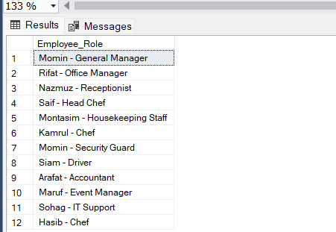

2. Show hotel names that start with ‘C’ and end with ‘w’:
→ select name from Hotel where Name like 'C%W'
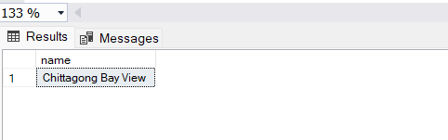

3. Show room typenames and prices sorted from least expensive to
most expensive:
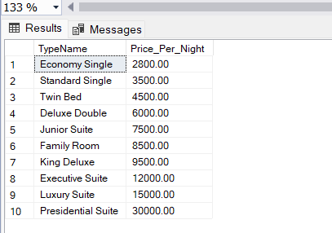
→ select TypeName, Price_Per_Night from RoomType order by Price_per_night

4. Show the maximum employee salary in each hotel, sorted from
highest to lowest:
→ select h.Name as HotelName, max(e.salary) as MaxSalary from Employee e join Hotel h on e.Hotel_ID = h.Hotel_ID group by h.Name order by MaxSalary desc
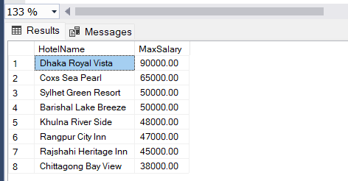

5. Show the total number of bookings per hotel, sorted by the hotel
with the most bookings:
→ select h.Name as HotelName, count(b.Booking_ID) as TotalBooking from Booking b join Hotel h on b.hotel_ID = h.Hotel_ID group by h.name order by TotalBooking desc
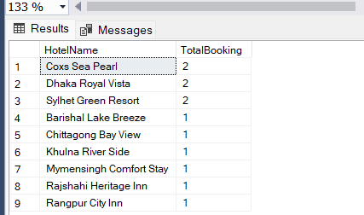

6. Show the average salary of employees for each hotel:
→ select h.name as HotelName, avg(e.salary) as AvgSalary from Employee e join Hotel h on e.Hotel_ID = h.Hotel_ID group by h.name
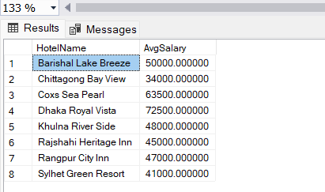

7. Display the total number of distinct guests who have booked rooms
in each hotel:
→ select h.name as HotelName, count(distinct b.Guest_ID) as TotalGuest from Booking b join Hotel h on b.Hotel_ID = h.Hotel_ID group by h.name
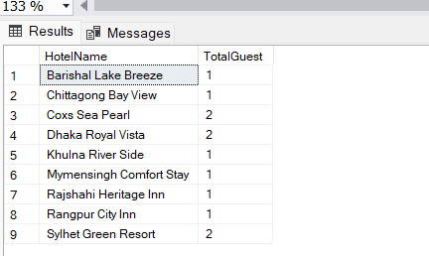

8. Count the total revenue generated from completed (Paid)
payments:
→ select sum(p.Payment_Amount) as TotalPayment from Payment p where p.Status = 'paid'
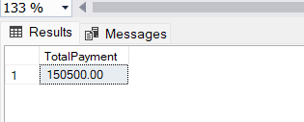

9. Show guest names who have ‘Pending’ payments:
→ select First_Name, Last_Name from Guest where Guest_ID in (select Guest_ID from Payment where Status = 'Pending')
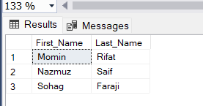

10. Find the guests who have made a total payment greater than
20,000.
→ select first_name, last_name from guest where guest_id in (select guest_id from payment group by guest_id having sum(Payment_Amount) > 20000)
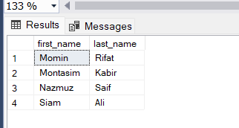

9. Data Base Objects
1. Trigger – Auto update room status after booking
→ create trigger After_Booking_Guest on Booking after insert as begin update Room set Status = 'Occupied' where Room_ID in (select Room_ID from inserted) end
insert into booking values(613,312,1,502,'2025-10-10','2025-10-12','Confirmed');
select Room_ID, Status from Room Where Room_ID = 502
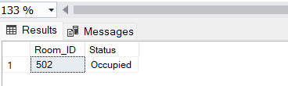

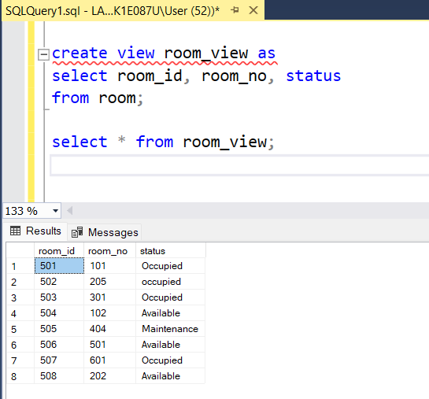
2. View – Room details

3. Function – Total payment per guest
→ create function Total_Payment (@Guest_ID int) returns decimal(10,2) as begin declare @total decimal(10,2); select @total = sum(Payment_Amount) from Payment where Guest_id = @Guest_ID; return @total; end
select dbo.Total_Payment(301) as Total_Payment

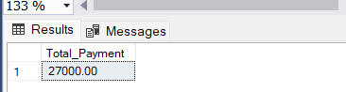

4. Stored Procedure – Per Day Booking Amount
→ create procedure Daily_Payment_Calc @Booking_Date date as begin select sum(Payment_Amount) as Total_Payment from Payment where Payment_Date = @Booking_Date end
exec Daily_Payment_Calc '2025-10-05'
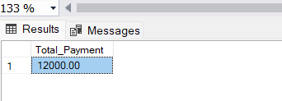

CEP Mapping
- How Knowledge Profiles (K’s) are addressed through our project and mapping among K’s, COs and POs –

K’s | Attributes | How K’s are addressed through our project | CO | PO
K3 | Engineering Fundamentals | The project applies database engineering fundamentals such as ER modeling, schema design, normalization, and SQL operations (DDL, DML) to ensure structured and optimized data management in the Hotel Management System. | CO1, CO2, CO3,  CO4 | PO1,  PO2
K5 | Engineering Design | This project includes designing entity relationships, schema diagrams, and database constraints (PK, FK, etc.). It also involves triggers, view, stored procedures, and functions to maintain consistency and reliability | CO3, CO4,  CO8 | PO2,  PO3
K6 | Engineering Practice | We used SQL Server (SSMS) to build, manage, and query our database. We created tables, inserted data, and executed queries practically. This shows engineering practice through use of tools, modularity, and efficient data handling. | CO1, CO2, CO5 | PO5,  PO8
K7 | Comprehension | The project enhances understanding of how data-driven systems improve hotel operations — managing bookings, payments, and guests efficiently. It promotes awareness of societal and organizational benefits through technology integration. | CO5,  CO6, CO7 | PO6, PO8

- How Complex Engineering problem solving (P’s) are addressed through our project and mapping among P’s, COs and POs –

P’s | Attributes | How P’s are addressed though our project | CO | PO
P1 | Depth of Knowledge Required | The project requires a deep understanding of DBMS concepts, including normalization, ER design, and data constraints. It translates a real-world hotel management scenario into an engineering database solution. | CO1,  CO3,  CO4,  CO5 | PO1,  PO2,  PO3,  PO5
P3 | Depth of Analysis Required | We analyzed relationships among Guest, Booking, Payment, and Room entities to ensure referential integrity and detect potential inconsistencies such as double bookings or unpaid reservations. | CO3,  CO4 | PO3
P7 | Interdependence | The system shows strong interdependence between components (Guest, Booking, Payment, Room, Hotel). A change in one table affects others, reflecting real-life operational dependencies in hotel management. | CO3,  CO4,  CO7 | PO2,  PO4,  PO7

- How Complex Engineering Activities (A’s) are addressed through our project and mapping among A’s, COs and POs –

A’s | Attributes | How A’s are addressed though our project | CO | PO
A1 | Range of Resources | We used SQL Server, ER diagramming tools, and data modeling software to design and implement our database. The activity required teamwork, computing resources, and domain knowledge of hotel operations. | CO1,  CO4,  CO7 | PO5
A5 | Familiarity | The project deals with familiar challenges in room bookings and customer payment management, while also addressing specific issues such as coordinating room availability with booking schedules and ensuring accurate payment processing. These tasks are common in the hospitality industry but require careful integration and data management. | CO4,  CO8 | PO10,

